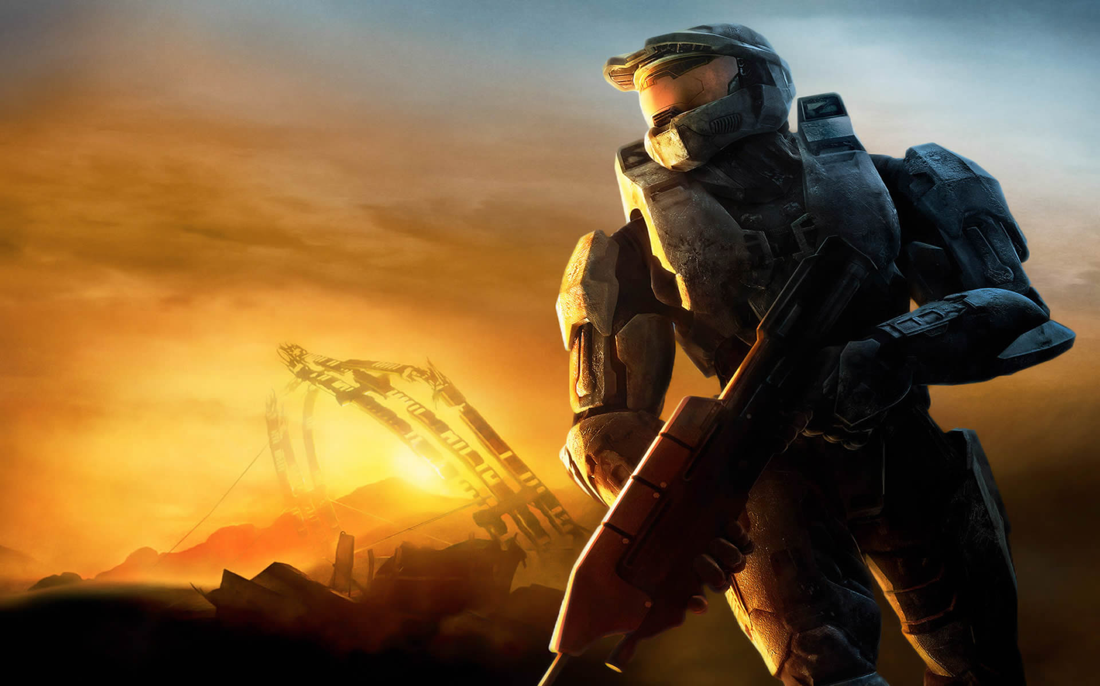

*Designed By*

*Aaron Kippins*

*Halo Database*

*Design Project*

**Table of Contents**

**ER-Diagram..........................................................................................................................................3**

**Summary…...........................................................................................................................................4**

**Overview................................................................................................................................................4**

**Entities...................................................................................................................................................5**

**Characters.................................................................................................................................5**

**Games........................................................................................................................................6**

**Species.......................................................................................................................................6**

**Planets.......................................................................................................................................7**

**Character Type...................................................... ..................................................................8**

**Game Location.........................................................................................................................8**

**Games Appeared................................. ....................................................................................9**

**Species Planet............................................................... .........................................................10**

**Character Species............................................................. .....................................................11**

**Views ................................................................ ..................................................................................12**

**Spartans..................................................................................................................................12**

**Marines....................................................................................................................................12**

**A.I……………........................................................................................................................13**

**Stored Procedures...............................................................................................................................14**

**SP: All games with a given character...................................................................................14**

**SP: All Characters within a given race…............................................................................15**

**Sample Reports...................................................................................................................................15**

**Query: What Species Is Master Chief?…………................................................................15**

**Query: What Planet Are The Sangheili from?....................................................................15**

**Query: What are the games in which Master Chief has appeared in?.............................15**

**Security................................................................................................................................................16**

**Known Issues.......................................................................................................................................16 Future Enhancements........................................................................................................................17**

**ER Diagram**

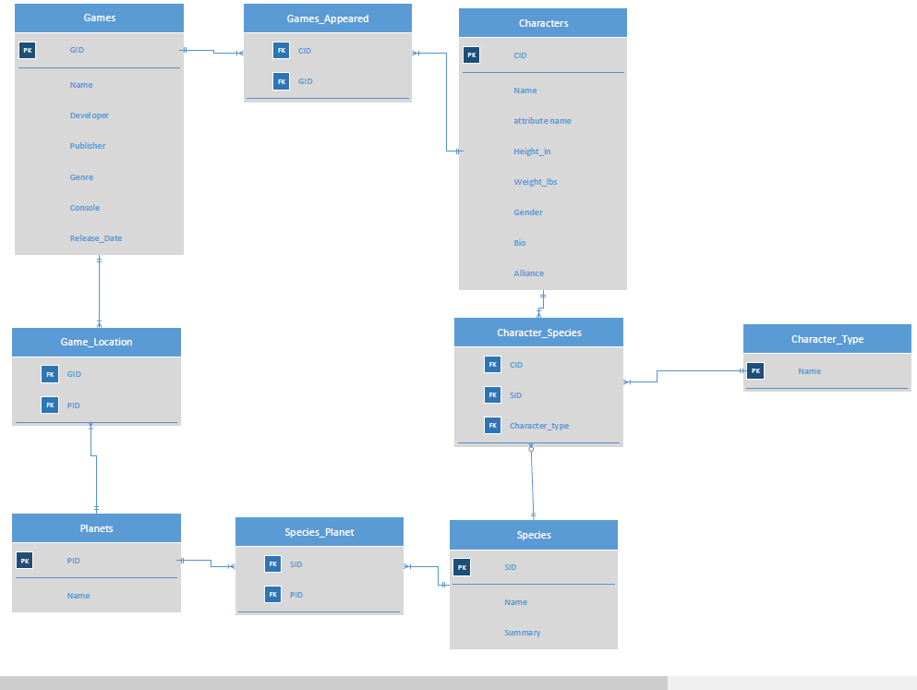

**Summary**

This document serves the purpose of revealing the design and implementation of a database made for the Halo Universe. This will be a central repository for all information related to the Halo franchise. We’ll start by showing an ER Diagram that will allow us to portray a brief description of our proposed solution for the Data Collection needs of Microsoft. We have also included is the purpose of each entity within the database as portrayed in the ER Diagram. The details will include the purpose of the table as well as the reasoning behind each entity and its design. Along with the detailed explanation we also provide the SQL statements that the Entities in the database were created with and alongside that sample results are also included. This will allow for a visual interpretation of the end result of our work and how it will provide a well-functioning database. In order to drive simplicity we also have included views and stored procedures that allow the user to implement complex queries in simple single line statements. These functions can be implemented by those in web design, application development, or project development within the Microsoft Corporation without having to do the difficult work of formulating complex queries. Just as we did with the Entities we also provide sample data for the user to visualize what exactly we are discussing. We’ll then show a collection of sample queries and close with a small discussion on security, some of the tradeoffs of our design and some enhancements that could be made in the future.

**Overview**

Based on the requirements outlined by Microsoft Corporation we believe our solution is suitable to their needs. Our goals for designing the database were based on the following observations.

* Once the initial database is made operational and the base data has been inserted, the database will require minimal effort in upkeep and adding new information to it while it is operational.
* Additions to the database will most commonly be inserted at the release of a new game, every few years or so after a game comes out of development. The database will be read only for the most part since insertion into the database won't usually be a common occurrence. This allowed us to make our design as easy as possible to use being only used to retrieve data in a majority of its uses allows us to focus our time in creating stored procedures that the user can just call. Because of this we try to allow the user to insert data simply and without altering the structure of the database.
* Since the popularity of the Halo universe is monumental and is the face of the Xbox console we wanted to also allow access to fan sites and any one curious about the universe. The number of fans and fan sites increase with every new game. Our database solution provides a public API to allow fan sites access to game data while keeping Microsoft's systems secure. Our database provides some stored-procedures that allow those that need to the ability to query the data using simple function calls. We also utilize views to increase usability and security.

Based on these observations we are confident that our database will meet your business requirements by providing you with a system that is easy to use, accessible, and secure.

**Entities**

**Characters**

The characters entity stores data on any sentient or artificial life form the plays a part in the Halo Universe. This includes supporting and non-playable characters from each game. This also serves as a log of the attributes of character and helps to show the main attributes of characters. By logging this we are more easily able to decipher the differences between similar characters. Attributes like hair and eye color are left out due to a good percentage of the characters not being human and having identifiable characteristics. Also added some things that are abnormal like being able to select genderless and players choice as a gender were needed since the characters are a part of a game and are intractable. It was also thought to let the bio be a field that allows nulls due to some of the characters being secondary (Not important enough for a bio entry) but still important. The field alliance reveals the faction that the character is dedicated to this helps to grasp basic insight on the characteristics of the individual.

--This is the creation of the Characters table

**create table** characters (

character_id serial **not null primary key**,

name text **not null**,

height_in int **not null default** 0.0 **check** (height_in > 0),

weight_lbs int **not null default** 0.0 **check** (weight_lbs > 0),

gender text **not null check** (gender = 'Male' or gender = 'Female' or gender = 'Genderless' or gender = 'Players Choice'),

bio text,

alliance text **not null check** (alliance = 'UNSC' or alliance = 'Covenant' or alliance = 'Flood' or alliance = 'Forerunner') not null

);

**Functional Dependencies: Character_id → Name, Height_in, Weight_lbs, Gender, Bio, Alliance**

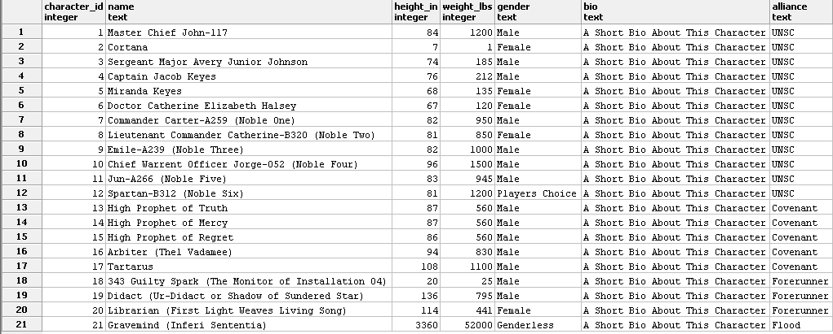

**Games**

The games entity is responsible for storing all of the data about the games in the Halo universe. The data stored here shows all who were involved in the making of the game and allows us to get a feel for how the games came to be and why they turned out the way they did. Including fields like platform released and genre allow insight into where the games series is headed in terms of consoles. Same with the developer field to determine where the story was focused and where it might be headed.

--This is the creation of the Games table

**create table** games(

game_id serial **not null primary key**,

name text **not null**,

developer text **not null**,

publisher text **not null**,

genre text **not null**,

platform_released text **not null check** (platform_released = 'Xbox' or platform_released = 'Xbox 360' or platform_released = 'Windows Phone 8'),

release_date date **not null**

);

**Functional Dependencies: Game_id → Name, Developer, Publisher, Genre, Platform_Released, Release_Date**

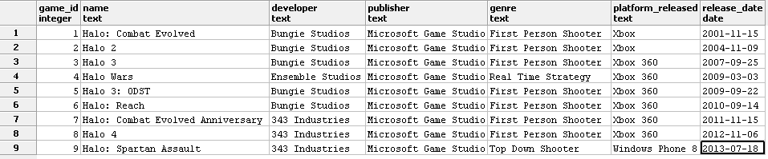

**Species**

The species entity in the table allows us to see all of the type of life involved in the creation of the story in game. It was decided that to keep things as simplistic as possible that all that would be inserted would be the name and a short summary on the race. A future enhancement here could be to allow a nickname field of some sort. This is because in the game none of the characters are referred to as the specie type because the humans have renamed them all and those are the names heard when referring to a race of sentient life.

--This is the creation of the Species table

**create table** species

(

species_id serial **not null primary key**,

name text **not null**,

summary text **not null**

);

**Functional Dependencies: Species_id → Name, Summary**

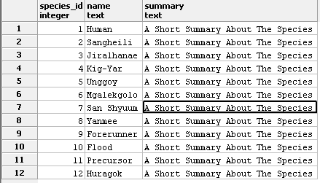

**Planets**

The Planets entity shows only the major locations that the games have taken place in. This is its own entity because it is referenced in multiple other tables. Only a name is required for this table.

--This is the creation of the Planets table

**create table** planets

(

planet_id serial **not null primary key**,

name text **not null**

);

**Functional Dependencies: Planet_id → Name**

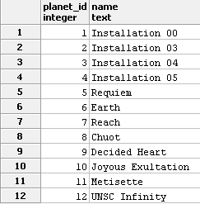

**Character Type**

Character Type serves the purpose of assigning subtypes to the alliances column. This serves a purpose in the case of specifying specifically what a person is responsible for within the alliance. This also makes it a little easier for the common user to navigate because the names used or the more common names for the races within the game.

--This is the creation of the Character Type table

**create table** character_type

(

name text **not null**

);

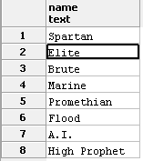

**Game Location**

Game location serves as the connecting link between the Games table and the Locations table. This table allows us to see the various locations in which a game has taken place. Having this as a separate entity allows for the entry of multiple locations to be in a single game. This also allows the user to input referenced locations from the games too. This table is reliant on the games and planets table for references to data to reduce the risk of update errors. This table is useful for queries such as “Where did Halo: Combat Evolved take place?”

--This is the creation of the Game Location table

**create table** game_location

(

game_id serial **not null references** games(game_id),

planet_id serial **not null references** planets(planet_id)

);

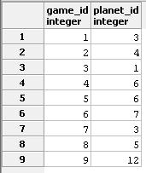

**Games Appeared**

Games Appeared serves as a link between the Games and Characters tables. This is required to show what characters appear in what particular games. This table is very important because it allows the user to keep track of what games a character has appeared in. This table would come in handy if a query would ask “What are the games in which Master Chief has appeared in?” It’s important to note that this table helps ensure that only valid Characters and Games are entered. You can only enter an id from the Games Table or the Characters Table.

--This is the creation of the Games Appeared table

**create table** games_appeared

(

character_id serial **not null references** characters(character_id),

game_id serial **not null references** games(game_id)

);

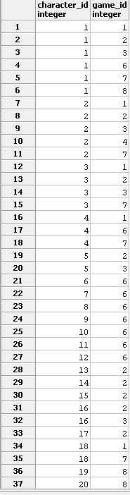

**Species Planet**

The species planet entity is responsible for telling the user what species in the games belong to what planets. This serves as a link between the species and planets table. This table is responsible for keeping track of where the many species of the games originate. This table is useful for queries like “What Planet are the Sangheili from?”

--This is the creation of the Species Planet table

**create table** species_planet

(

species_id serial **not null references** species(species_id),

planet_id serial **not null references** planets(planet_id)

);

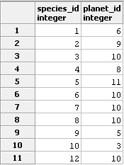

**Character Species**

The character species entity shows the species of all of the characters in the halo universe. This table allows the user to simply refer to this table whenever they want to find the specific race of any of the characters. This table also serves as a link between the character table and the species table. This is similar to the previous three in which it refers to two other tables in order to reduce update anomalies. We would refer to this table is someone was to ask “What species is Master Chief?”

--This is the creation of the Character Species table

**create table** character_species

(

character_id serial **not null references** characters(character_id),

species_id serial **not null references** species(species_id)

);

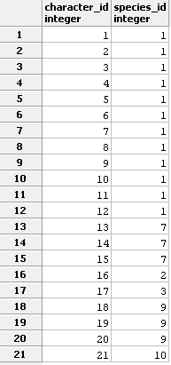

**Views**

The following section demonstrates the creation and use of a few views. The view names are in bold font and are followed by a sample SQL statement used to query the view, sample data

generated from the query, and the SQL statements used to define the view.

**Spartans**

**Select * From spartan**

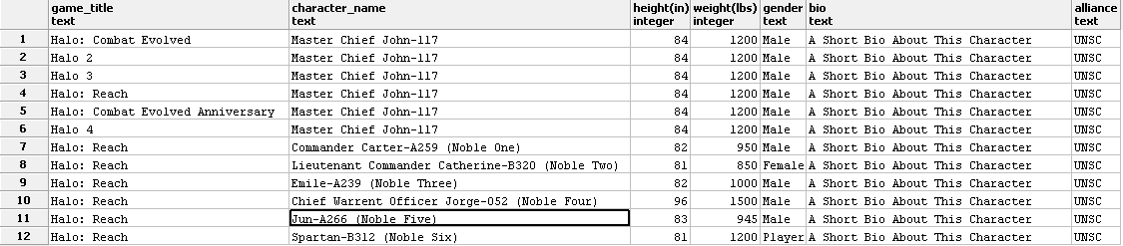

**create view** spartans **as**

**select** games.name **as** game_title,

characters.name **as** character_name,

characters.Height_in **as** "height(in)",

characters.Weight_lbs **as** "weight(lbs)",

characters.gender **as** gender,

characters.Bio **as** Bio,

characters.alliance **as** Alliance

**from** games, games_appeared, Characters, character_species

**where** games.game_id = games_appeared.game_id **and**

games_appeared.character_id = characters.character_id **and**

characters.character_id = character_species.character_id **and**

character_species.character_type = 'Spartan'

**Marines**

**Select** * **From** marine

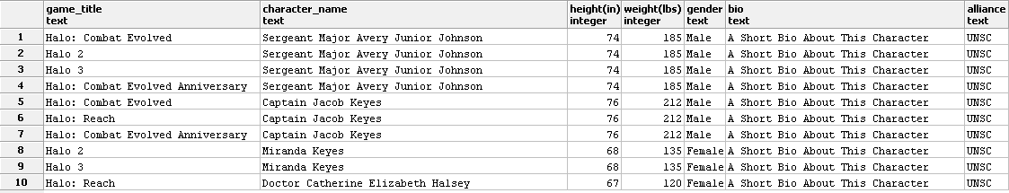

**create view** marines **as**

**select** games.name **as** game_title,

characters.name **as** character_name,

characters.Height_in **as** "height(in)",

characters.Weight_lbs **as** "weight(lbs)",

characters.gender **as** gender,

characters.Bio **as** Bio,

characters.alliance **as** Alliance

**from** games, games_appeared, Characters, character_species

**where** games.game_id = games_appeared.game_id **and**

games_appeared.character_id = characters.character_id **and**

characters.character_id = character_species.character_id **and**

character_species.character_type = ‘Marine’

**A.I.**

**Select** * **From** AI

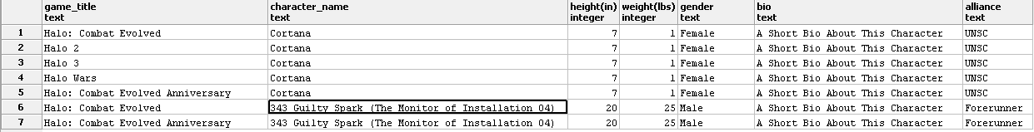

**create view** AI **as**

**select** games.name **as** game_title,

characters.name **as** character_name,

characters.Height_in **as** "height(in)",

characters.Weight_lbs **as** "weight(lbs)",

characters.gender **as** gender,

characters.Bio **as** Bio,

characters.alliance **as** Alliance

**from** games, games_appeared, Characters, character_species

**where** games.game_id = games_appeared.game_id **and**

games_appeared.character_id = characters.character_id **and**

characters.character_id = character_species.character_id **and**

character_species.character_type = ‘A.I.’

**Stored Procedures**

The following section demonstrates the use of stored procedures to query the database for information. These procedures can be called through a web-interface or application program and will return the information specified by the user input

**SP: All Games with a given Character**

Procedure Call: **Select** listgames(‘Cortana’)

**create function** listgames(Halo_Character text)

returns **table** (Name text, publisher text) as $$

begin

**return** query **select** games.name, game.publisher

**from** games, game_appeared, characters

**where** games.game_id = games_appeared.game_id **and**

games_appeared.character_id = characters.cid **and**

characters.name = Halo_Character;

end;

$$ **language** plpgsql

**SP:All Characters within a given race**

**create function** listnames(Race_name text)

returns **table** (Name text, publisher text) as $$

begin

**return** query **select** characters.name, character.alliance

**From** characters, character_species, species

**where** characters.character_id = character_species.character_id **and**

character_species.species_id = species.species_id **and**

species.name = Race_name;

end;

$$ **language** plpgsql

**Sample Reports**

The following section demonstrates how the database can be queried to generate useful information.

**Query: What species is Master Chief?**

**select** species.name

**from** species, character_species, characters

**where** species.species_id = character_Species.Species_id **and**

character_species.character_id = characters.character_id **and**

characters.name = 'Master Chief John-117'

**Result: Human**

**Query: What Planet are the Sangheili from?**

**select** planets.name

**from** planets, species_planet, species

**where** planets.planet_id = species_planet.planet_id **and**

species_planet.species_id = species.species_id **and**

species.name = 'Sangheili'

**Result: Decided Heart**

**Query: What are the games in which Master Chief has appeared in?”**

**select** games.name

**from** games, games_appeared, characters

**where** games.game_id = games_appeared.game_id **and**

games_appeared.character_id = characters.character_id **and**

characters.name = 'Master Chief John-117'

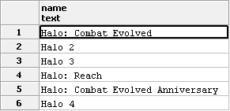

**Security**

We made the decision to form two user-types with the following usage requirements.

* DBA: The DBA performs general upkeep of the database. This may include updating game info for games that are still in production, inserting data for new games or characters, and correcting any exsiting error or conflicts in the database. These operations require full read and write access to all of the views and the base tables. The following SQL statement explains how to create a DBA role and enable access to the operations needed to perform upkeep.

**CREATE ROLE** dba

**GRANT SELECT, INSERT, UPDATE**

**ON ALL TABLES IN** SCHEMA PUBLIC

**TO** dba

* Public User: The public user is restricted to performing only select operations on the views and to only a select few of the base tables. The public user could represent an application developer or a web-designer looking to create a fansite or just a normal person who wants access to the games data. This user should have minimal knowledge of the base tables. The data that we hold in our database is not for the most part sensitive, but a malicious user could still use the knowledge of our database structure to destroy the database of portray an image that we do not wish to represent. The following SQL statements demonstrate one method for creating a public user.

**CREATE ROLE** public_user

**GRANT SELECT**

**ON** bonds, villains, henchmen, movies

**TO** public_user

Additional security measures, such as secure authentication, will depend on the host system and on the chosen DBMS.

**Known Issues**

* The current design only allows for the characters to be allied with one faction, this is a problem going from Halo 2 to Halo 3. The Arbiter in between the games becomes an ally to the UNSC this isn’t properly portrayed in the database because of this error.
* Currently the flood is listed as being genderless, when in actuality it can actually be Genderless, Male, or Female depending on its mutation. So there is technically an error because the flood consumes and absorbs the physical traits if the sentient life that it consumes

**Future Enhancements**

Some features to consider for future updates.

* Query the database for Recognizable skulls.
* Query the database by Chapter within the games.
* Query the Skulls within the game, what they do and in some cases where they are located
* Retrieve the Game awards
* Retrieve the Games soundtrack information for each game.